APPLICATION FOR EMPLOYMENT

CSHQA is an Equal Employment Opportunity employer and considers all qualified applicants regardless of their race, color, religion, sex, sexual orientation, gender identity, national origin, protected veteran or disabled status.
Click here for more information about Equal Employment Opportunity Law and Equal Employment Opportunity Supplement.

Today’s Date:

Each question should be fully and accurately answered. No action can be taken on this application until all questions have been completed. All information given will be available only to persons who have a “need to know” or as required by law. This company will make reasonable accommodation in the application process, if needed. In order to be considered for any position with CSHQA, you must submit a cover letter, resume, portfolio (if required) and completed application to hr@cshqa.com.
This application is current only for thirty (30) days, at the conclusion of which time, if you have not heard from us and still wish to be considered for employment, it will be necessary for you to fill out a new application.

PERSONAL DATA
Last Name First Middle Other names used in past employment
Address City State Zip Code Home Phone Message Phone
Position for which you are applying Wage or Salary Desired E-Mail

EDUCATION | School | City and State | Major | Type of Degree/Diploma | GPA | Graduate
High School/GED |  |  |  |  |  | Yes No
College/University |  |  |  |  |  | Yes No
Post Graduate Degree |  |  |  |  |  | Yes No
Technical/Vocational |  |  |  |  |  | Yes No

PROFESSIONAL REGISTRATIONS (List all professional licenses/certifications)
Discipline | States Licensed | Year | License No.’s | Has disciplinary action ever been taken?

SKILLS

List all hardware, software and industry related skills (models, presentations, photography etc.) you are accomplished in

Are you capable of satisfactorily performing the essential duties required of the position you are applying for? Yes No Are you authorized to work in the United States? Yes No
It is the policy of CSHQA not to discriminate against any employee or applicant for employment because of his/her race, color, religion, sex, sexual orientation, gender identity, national origin, national origin groups, age, pregnancy, genetic information, retaliation for protected activity, or any other status protected by applicable federal, state and local laws, or because he/she is an individual with a disability or disabled veteran, Armed Forces service medal veteran, recently separated veteran, or active duty wartime or campaign badge veteran, or thereinafter referred collectively as “protected veterans.” It is also the policy of CSHQA to take affirmative action to employ and to advance in employment, all persons regardless of their status, as described above, and to base all employment decisions only on valid job requirements. This policy shall apply to all employment actions, including but not limited to recruitment, hiring, training, upgrading, promotion, transfer, demotion, layoff, recall, termination, rates of pay or other forms of compensation and selection for training, including apprenticeship, at all levels of employment.
Are you over 18 years of age? Yes No

How were you referred to CSHQA?
Advertisement Friend Walk-in Recruiting Firm Current Employee Other

Are you currently employed? Yes No

In compliance with ADA Amendments Act (ADAA), if you have a disability and would like to request an accommodation in order to apply for a position with CSHQA, please contact Ruthie Heikkila at
208-343-4635 or hr@cshqa.com.

WORK EXPERIENCE
Dates of  Employment: From Month/Day/Year To Month/Day/Year |  | Job Title | Supervisor’s Name & Title
Company Name | List Duties and Responsibilities:
Address
City and State
Phone | Reason For Leaving:
Dates of  Employment: From Month/Day/Year To Month/Day/Year |  | Job Title | Supervisor’s Name & Title
Company Name | List Duties and Responsibilities:
Address
City and State
Phone | Reason For Leaving:
Dates of  Employment: From Month/Day/Year To Month/Day/Year |  | Job Title | Supervisor’s Name & Title
Company Name | List Duties and Responsibilities:
Address
City and State
Phone | Reason For Leaving:
REFERENCES (Business/professional only)
Name | Title | Years Known | Email | Phone
Name | Title | Years Known | Email | Phone
Name | Title | Years Known | Email | Phone
This Employment Application is used to notify me that the nature and scope of an investigation, if one is conducted, could include such general identification information as residence verification, and, as applicable, information concerning my employment, education, general reputation, character, personal characteristics, and habits, and that such information may be developed through personal interviews with third parties such as family members, neighbors, friends, associates, former employers, educational institutions, custodians of official records or other sources. Only job-related information developed from such a report will be considered in evaluating my employment application or continued employment. I hereby authorize these persons, companies, organizations or corporations to answer all questions or release any information regarding the items listed in this paragraph. I hereby release them from any liability and hold them harmless from any claim for releasing any truthful information within their knowledge and/or records.

I authorize the Company to release to any person, firm, entity or organization with which I may seek employment in the future, any truthful information concerning my work experience with the Company. I hereby release and hold the Company harmless from any claim for releasing any truthful information within its knowledge and/or records.
I understand that any job offer that may be extended to me will be contingent upon the successful completion of a drug and alcohol test.

I certify that the answers given by me to the foregoing questions and during any interviews are true and correct without consequential omissions, and understand that, if employed, omissions and/or false statements on this application or during any interviews may result in dismissal. I understand and acknowledge that, if hired, my employment is for no definite period and either the Employer or I may terminate our relationship at will at any time, without notice or any reason, and that this employment application does not constitute an employment contract. I have had an opportunity to have my questions about this statement's content and intent answered and understand its terms.

Date Signature of Applicant

DRUG-FREE WORKPLACE POLICY

Purpose:
CSHQA, a professional association, is committed to providing a workplace environment, which ensures the safety, and encourages the personal health and productivity of its employees.

Policy:
CSHQA, a professional association, recognizes substance abuse in the workplace to be a threat to the safety, health and job performance of all employees. In general, substance abuse includes use, possession, manufacturing, distribution, and being under the influence of alcohol, or other drugs, including inappropriate use/abuse of prescription and over the counter drugs. It is therefore the policy of CSHQA, a professional association, that the above described activities are strictly prohibited during working hours, on company property, during use of a company vehicle, and when performing company business, regardless of the time or location (responsible consumption of alcohol on company premises during company sponsored events is an exception).

Procedure:
- Any activity involving an illegal substance, including use (defined as the presence of an illegal substance in a persons system, see cut off levels below), possession, manufacturing, or distribution (purchasing, giving away, or otherwise dispensing) is strictly prohibited. Any activity involving an illegal substance, while on the job, will have a direct bearing on an employee’s standing within the organization. Any conviction by a law enforcement agency for illegal drug activity may be cause for dismissal from employment.

Drugs which are “illegal” include but are not limited to marijuana, cocaine and crack, opiates, amphetamines and phencyclidine (PCP and angel dust).

- Abuse of a legal substance, including alcohol, prescription, and over the counter drugs is strictly prohibited. Prohibited activities, involving legal substances, may include: use, possession, distribution or being under the influence of alcohol while on the job; use, possession, distribution, or being under the influence of drugs that are legally obtainable, but have not been obtained legally; and use of a drug in a manner, or for a purpose other than which it was intended or prescribed.

Note: Use of a prescription drug that has been prescribed by an employee’s physician is permissible during work hours, but may require certification by a physician as to the ability of the employee to perform his/her job in a safe manner. The employee should notify his/her supervisor or Human Resources if use of properly prescribed drug will affect work performance. No employee will be disciplined for the authorized and necessary use of a prescription drug. Abuse of a prescription drug and unauthorized use without a prescription from a licensed physician are prohibited.

Use of Company property, or one’s position within the company to facilitate any illegal or prohibited drug activity, as defined in this policy is strictly prohibited.

Any employee who violates this policy is subject to disciplinary action, which may include suspension without pay, required participation in a drug assistance program, possible referral for substance abuse, treatment or termination from employment.

This policy is not an express or implied contract of employment nor is it to be interpreted as such. Additionally, this policy does not in any way affect or changes an employee’s at-will employment relationship. At-will employees continue to be free to terminate their employment at any time and CSHQA continues to be free to terminate employee, with or without cause, with or without notice, for any lawful reason or for no reason at all.

When Testing will be conducted
- Pre-Employment Testing

  - Candidates for employment must successfully pass a drug-screening test to be eligible for employment or placement. Any offer made to a job candidate before that candidate has passed a drug test shall be contingent on that candidate passing the test. This test will conform to the pre-employment standards of Idaho law. Alcohol testing will not be conducted in pre-employment screening.

- Post-Hire Testing

  - Drug testing (including alcohol) of incumbent employees shall be conducted as follows:

    - All employees involved in an on-the-job accident (OSHA recordable) will be immediately asked to submit to a drug test. Under certain state laws, employees testing positive may be ineligible for, or receive, reduced workers compensation benefits.
    - All employees who have given Management reasonable cause to suspect intoxication or drug use on the job, or who exhibit impaired behavior, which may be alcohol or other drug-related problems, will also be tested.
    - An employee, who has been rehabilitated after a first, positive test result, will be subject to additional testing for a minimum of twelve months.

- Re-tests

  - An employee, testing positive for drugs or alcohol must receive written notice of the test result obtained. The employee must also be given an opportunity to discuss and explain the positive test result with a medical resource officer (MRO) or other qualified person. Note the MRO is not the same person as the Drug Program Coordinator described in this policy.
  - An employee or prospective employee may request that the original specimen be re-tested by a mutually agreed upon laboratory following their completion of step one. The re-test must be done within seven (7) working days from the date of the first confirmed positive test notification and may be paid for by the employee or prospective employee requesting the test. If the retest results are negative, the employer will reimburse the employee the cost of the retest, compensate the employee if he/she has been suspended without pay, or reinstate the employee with back pay if the employee was terminated solely because of the positive test.

Drug and Alcohol Testing Procedures
- All employees, including associates, principals and officers of the company, are expected to cooperate fully in providing specimens and explanations, which may be subsequently required by this procedure. Failure to provide an explanation, attempts to contaminate a specimen or other interference with alcohol or drug testing procedures, will be grounds for disciplinary action, up to and including discharge from employment.

- A signed and approved Informed Consent Statement is required before a specimen may be collected. An individual’s refusal to sign the Informed Consent Form, or to deliver a specimen as directed, will be considered insubordinate behavior for purposes of employment decisions, and will result in disciplinary action, up to and including discharge from employment.

- Any drug or alcohol testing shall occur during or immediately after the regular work period of current employees and shall be deemed work time for purposes of compensation and benefits for current employees.

- Sample testing shall conform to scientifically accepted analytical methods and procedures.

  - Drug testing will be done from urine specimens collected under highly controlled conditions. Specimen collection procedures require a designated collection site, chain of custody documentation, use of authorized personnel, privacy during collection, integrity and identity of specimen and transportation to the laboratory.
  - Employee protection will be built into the testing procedures. In order to meet the highest standards, only laboratories that are certified by the Substance Abuse and Mental Health Services Administration (SAMHSA) will be used.
  - Testing shall include verification or conformation of any positive results by gas chromatography-mass spectrometry (GC/MS), or other comparably reliable analytical methods, before the Company will use the result of any test as a basis for any action.

- Drug screening cut-off levels: CSHQA, a professional association screening and confirmation cut-off levels (recommended by the Department of Health and Human Services) for the drugs being tested for are as follows:

Substance | Screening  Cut-off | Confirmation  Cut-off
Cannabinoids as Carboxy-THC (Marijuana) | 100 NG/ML | 50 NG/ML

Cocaine Metabolites  As Benzoylecgonine | 300 NG/ML | 150 NG/ML
(Crack, Cocaine)
Phencyclidine (PCP, Angel Dust) | 25 NG/ML | 25 NG/ML
Opiates | 2000 NG/ML | 2000 NG/ML
Amphetamines  (Amphetamines & Methamphetamines*) | 1000 NG/ML | 500 NG/ML
Benzodiazepines  (Cocaine-like, RX “Uppers”) | 300 NG/ML | 100 NG/ML
Barbiturates  (Valium, Tranquilizers, Quaaludes, RX “Downers”) | 300 NG/ML | 200 NG/ML
Alcohol | .04 | .04

*Must also contain amphetamines equal to greater than 200 NG/ML

- Testing for Alcohol

The company may conduct a blood alcohol or Breathalyzer test on an employee to detect the presence of alcohol. An employee who has a blood alcohol or breathalyzer test result above 0.04 weight per volume shall not be allowed to work, but shall be driven home by a co-worker and, thereafter, subject to disciplinary action.

Workplace Responsibilities
- Intoxication on the job

  - It will be the responsibility of each employee to report to work in a condition that is conducive to performance of his/her work function, and maintenance of a safe work environment. No employee shall be allowed to work while under the influence of alcohol or illegal drugs. An employee that is determined to be in violation may be subject to disciplinary action. All employees, who are believed to be intoxicated, while on the job, or unable to work due to medication, will either be sent home, or to a medical facility. A manager or Human Resources will determine a safe means of transportation to the employee’s home, or medical facility. If needed, a manager or Human Resources will accompany the employee to a medical facility or home. Any employee that appears to be impaired by the use of any substance will not be allowed to drive.

- Violations involving illegal drugs, prescription drugs, or alcohol

  - Any employee may be terminated for any of the following prohibited acts:

    - Manufacture or distribution of illegal drugs on company property.
    - Personal possession or use of alcohol or illegal drugs on company premises, in a company vehicle, at a company worksite, on company business or while representing company interests (responsible consumption of alcohol on company premises during company sponsored events is an exception). Use will be defined as the presence of metabolites in bodily fluids.
    - Conviction by a court of law for possession with intent to distribute illegal drugs or controlled substances.

Management Responsibilities
- CSHQA will conduct training of team leaders, stockholders, project managers to ensure they understand and are prepared to perform their responsibilities. It will be the responsibility of the stockholders, team leaders, and project managers to:

  - Understand CSHQA’s intent and policy to maintain a drug free workplace.
  - Comply with, and implement the Company’s policy and programs.

Confidentiality
A. It is CSHQA policy and legal obligation to assure the confidentiality of all information, interviews, reports, statements, memoranda, and test results which are developed, received, or generated as a consequence of the implementation of this policy and testing program. Use of any information generated as a result of this policy will be restricted to the pursuit and achievement of those purposes and objectives as defined in the policy statement.

- END OF DOCUMENT -

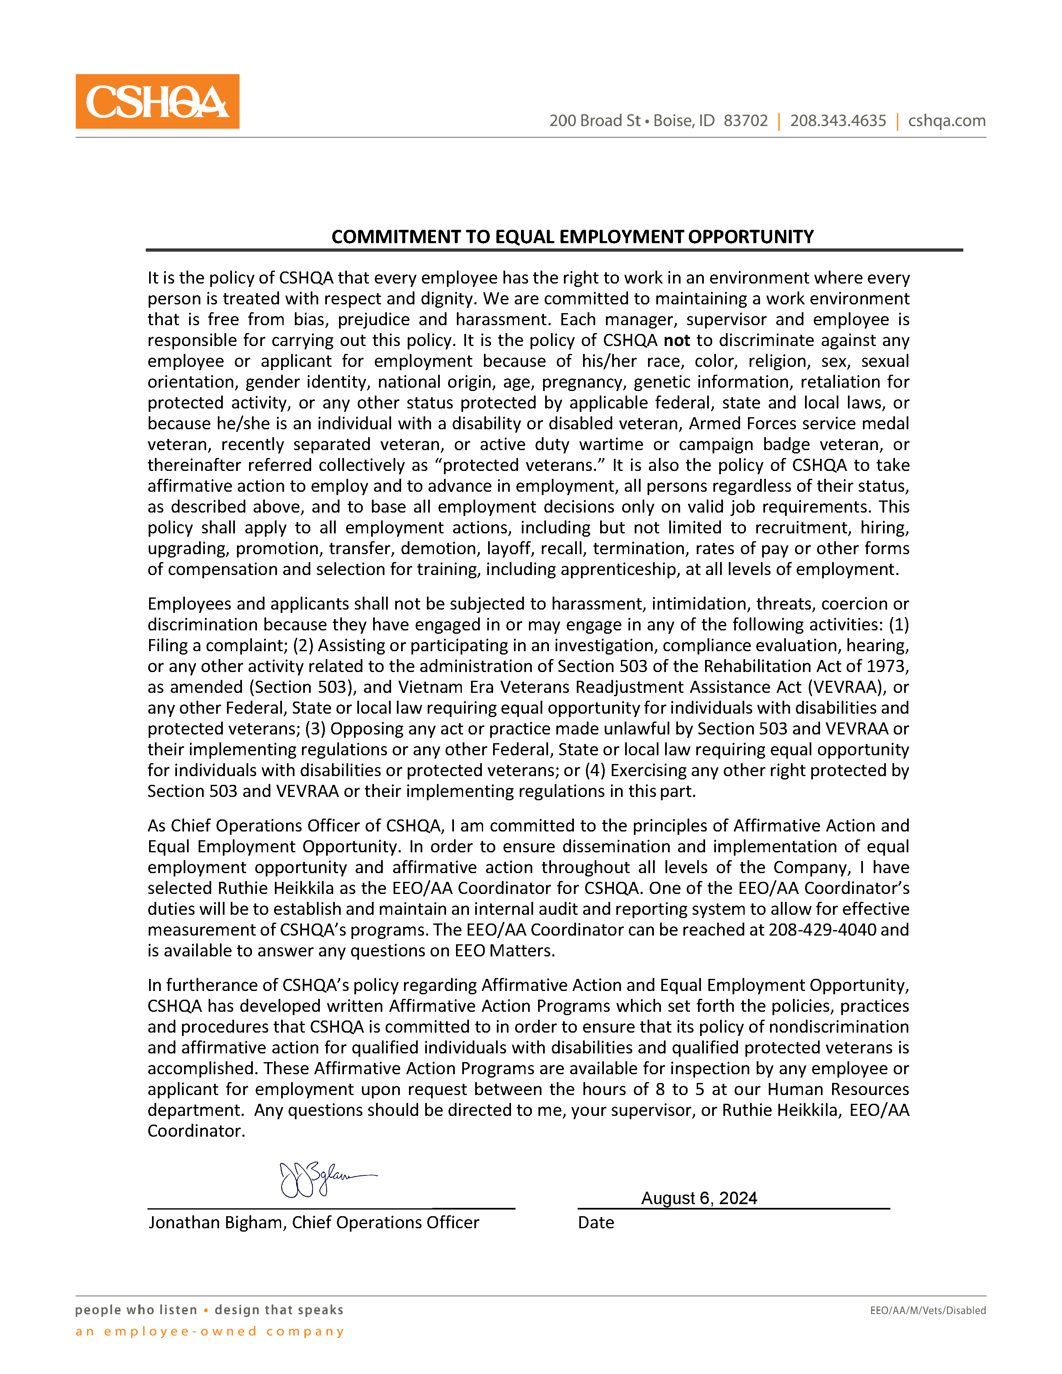

CSHQA

EEO/AA
Pre-Offer Voluntary Self-Identification Information
CSHQA is an EEO/Affirmative Action Employer

We consider all applicants for positions without regard to race, color, religion, sex, sexual orientation, gender identity, national origin, age, mental or physical disabilities, veteran status, and all other characteristics protected by law. We also comply with all applicable laws including E.O. 11246 and the Vietnam Era Readjustment Assistance Act of 1974, as
amended, governing employment practices and do not discriminate on the basis of any unlawful criteria. As a federal government contractor, we take affirmative action on behalf of protected veterans.
In an effort to comply with requirements regarding government recordkeeping, reporting, and other legal obligations that which may apply, we invite you to complete this applicant data survey. Failure to provide information will not subject you to any adverse personnel decision or action. Your cooperation is appreciated, but is entirely voluntary.
Please be advised that this survey is not a part of your official application for employment. It will not be used in any hiring decision. The information will be used and kept confidential in accordance with applicable laws and regulations.
Position applying for: |  |  | Date:
REFERRAL SOURCE
State Workforce Agency |  | Company Website | Employment agency
Advertisement |  | Online | School
Employee Referral |  |  | Other
APPLICANT INFORMATION
Name:
Address: | Last First Middle
Street City State ZIP
Home Phone: |  | Business phone/Cell phone:
ETHNICITY/RACE CATEGORIES
ETHNICITY/RACE: (identify one or more race categories)(definitions on the back)

Hispanic or Latino or identify a race listed below
White (not Hispanic or Latino) |  | Black or African American (not Hispanic or Latino) | Asian (not Hispanic or Latino)
Native Hawaii or Other Pacific Islander (not Hispanic or Latino)  I Do not wish to identify |  | American Indian or Alaska Native (not Hispanic or Latino) | Two or more races  (not Hispanic or Latino)

CSHQA

GENDER CATEGORIES
Male Female | I Do Not Wish to Identify

PROTECTED VETERAN CATEGORIES
I am a Protected Veteran I am Not a Protected Veteran I Do Not Wish to Identify

DEFINITIONS
ETHNICITY/RACE CATEGORY DESCRIPTIONS:

Hispanic or Latino includes a person of Cuban, Mexican, Puerto Rican, South or Central American, or other Spanish culture origin, regardless of race.

White (not Hispanic or Latino) includes a person having origins in any of the original peoples of Europe, North Africa, or the Middle East, or North America.

Black or African American (not Hispanic or Latino) includes a person having origins in any of the Black racial groups of Africa.

Native Hawaiian or Other Pacific Islander (not Hispanic or Latino) includes a person having origins in any of the peoples of Hawaii, Guam, Samoa, or other Pacific Islands.

Asian (not Hispanic or Latino) includes a person having origins in any of the original peoples of the Far East, Southeast Asia, or the Indian subcontinent including, for example, Cambodia, China, India, Japan, Korea, Malaysia, Pakistan, the Philippine Islands, Thailand, and Vietnam.

American Indian or Alaskan Native (not Hispanic or Latino) includes a person having origins in any of the original peoples of North America and South America (including Central America), and who maintains tribal affiliation or community attachment.

Two or More Races (not Hispanic or Latino) includes a person who identifies with more than one of the above races.

PROTECTED VETERAN CATEGORY DESCRIPTIONS:

A Disabled Veteran includes any veteran of the U.S. military, ground, naval or air service who: (a) is entitled to compensation, or who but for the receipt of military retired pay would be entitled to compensation under laws administered by the Secretary of Veteran Affairs, or (b) was discharged or released from active duty because of service-connected disability.

Active Duty Wartime or Campaign Badge Veteran includes any veteran who served on active duty in the U.S. military, ground, naval or air service in a war, campaign or expedition in which a campaign badge has been authorized under the laws administered by the Department of Defense.

Recently Separated Veteran includes any veteran during the three-year period beginning on the date of such veteran's discharge or release from active duty in the U.S. military, ground, naval or air service.

Armed Forces Service Medal Veteran includes any veteran who, while serving on active duty in the U.S. military, ground, naval or air service, participated in a United State military operation for which an Armed Forces service medal was awarded pursuant to Executive Order 12985.

